**Finding the best spot for opening a new restaurant in Calgary**

# Introduction

Opening a new restaurant is a challenge that those who love food and serving it to others take on. There are so many factors leading to a successful restaurant and, location is one the most important ones. A restaurant can have a very delicious food and warmest atmosphere but, in order to maintain a healthy financial status, it should be placed in the best location to attract the largest number of customers possible. In this project I am going to use data science techniques to find the most suitable neighborhoods for opening a new restaurant in Calgary.

## Background

Calgary is the largest city in Alberta with 1.24 million population. It has more than 180 neighborhoods and more than 3000 restaurants. If we compare Calgary with Toronto which has around 16000 restaurants for its 2.93 million population, we can see that there is a lot of room for growth in the restaurant business in Calgary. There are two main categories for neighborhoods in Calgary which are residential and industrial. there could be a case for opening a new restaurant in an industrial neighborhood, but my main focus would be on residential neighborhoods for this project.

# Data

For this project I have used the following sources :

* [Calgary neighborhood data from Wikipedia](https://en.wikipedia.org/wiki/List_of_neighbourhoods_in_Calgary)
* [Calgary neighborhood venue data from Foursquare](https://developer.foursquare.com/docs/places-api/)

These sources are used to extract data for neighborhoods and restaurants in Calgary. after analysing and modeling the data we will have an insight on the proper locations to open a new restaurant as well as what type of restaurant might have a better chance in each neighborhood.

## Calgary neighborhoods data

Calgary neighborhoods extracted from Wikipedia is presented in the table below:

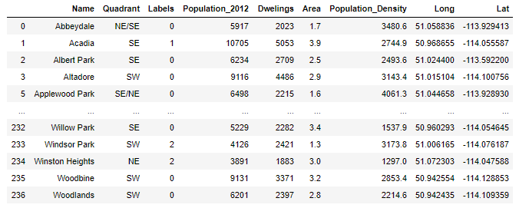

After applying K-means clustering on this data the neighborhoods in 5 clusters can be seen on the following map:

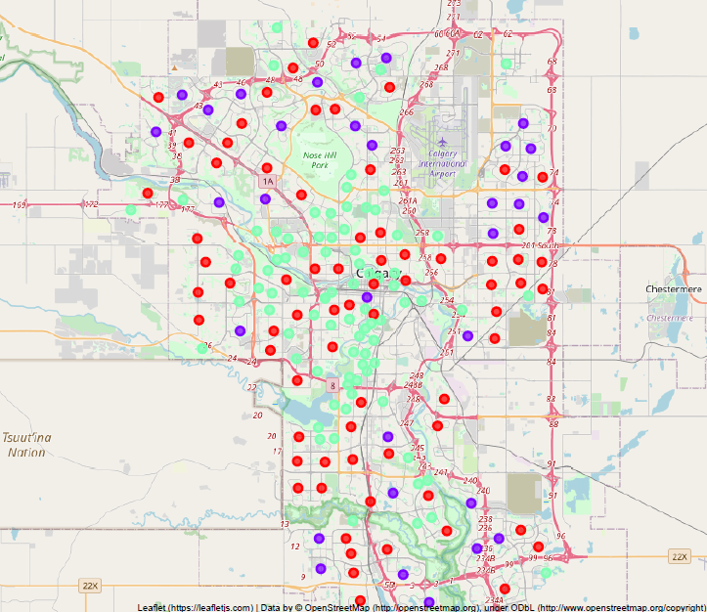

## Calgary restaurants data

Calgary restaurants data extracted from Foursquare is presented in the table below:

